TSNE Visualizations:

*In all the visualizations the component 1 is along x axis and component 2 is along y axis.*

1. **<Category, attribute> : <Kurti, Black>**

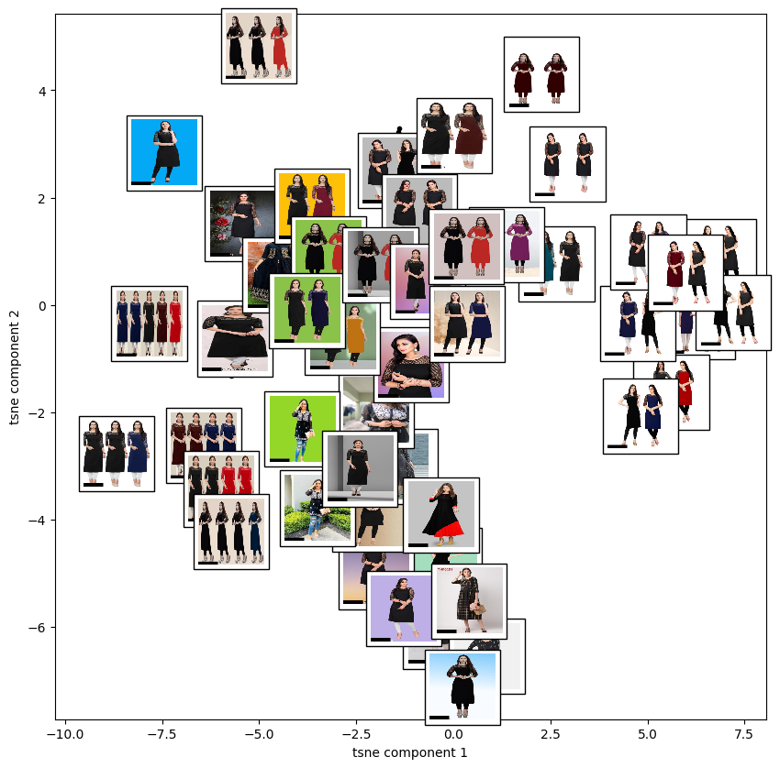

* *The component 1 captures the variations in the background colour as it is evident that the pictures in the left have coloured background and most of the pictures to the right have white background.*
* *The component 2 captures the different poses of model in the picture. It is evident from the picture that there exists lots of variations in the pose from bottom up*.

1. **<Category, attribute> : <Kurti, aline>**

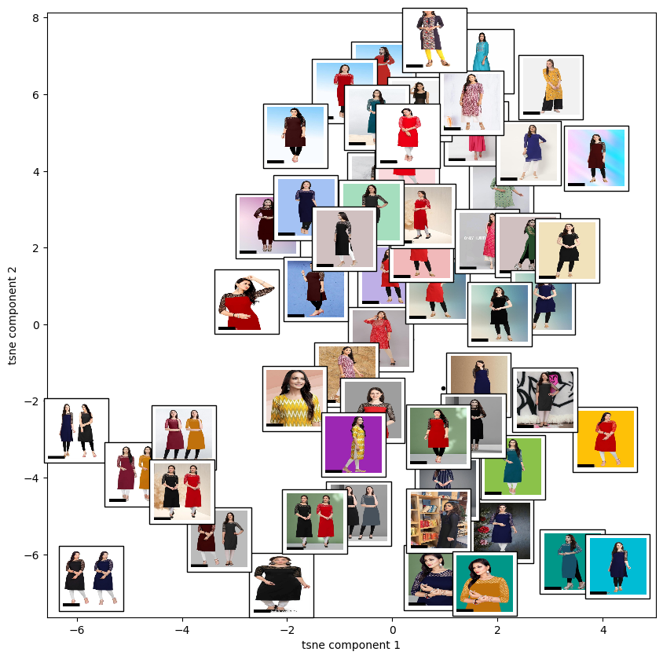

* *The component 1 captures the variations in the length of the sleeve and the design of sleeves. It is evident that the left clustered images have longer sleeve length and plain design whereas the right clustered images have shorted sleeve length and there is some different transparent design.*
* *The component 2 captures the variations in the colour of the kurtis . From the image we could observe that the colour of the kurtis is lighter at the top when compared to the middle and bottom.*

1. **<Category, attribute> : <Men Tshirts, polo>**

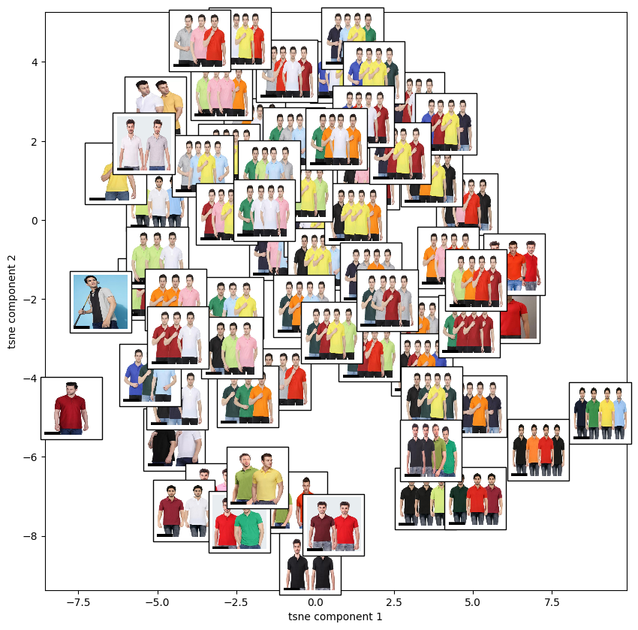

* *The component 1 captures the number of models in the pictures. It is evident that at left there are fewer models in the picture and towards right there 4 models in each picture.*
* *The component 2 captures the variations in the colour of Tshirts. From the image we could observe that the colour of tshirts is lighter at the top when compared to the bottom.*

1. **<Category, attribute> : <Men Tshirts, white>**

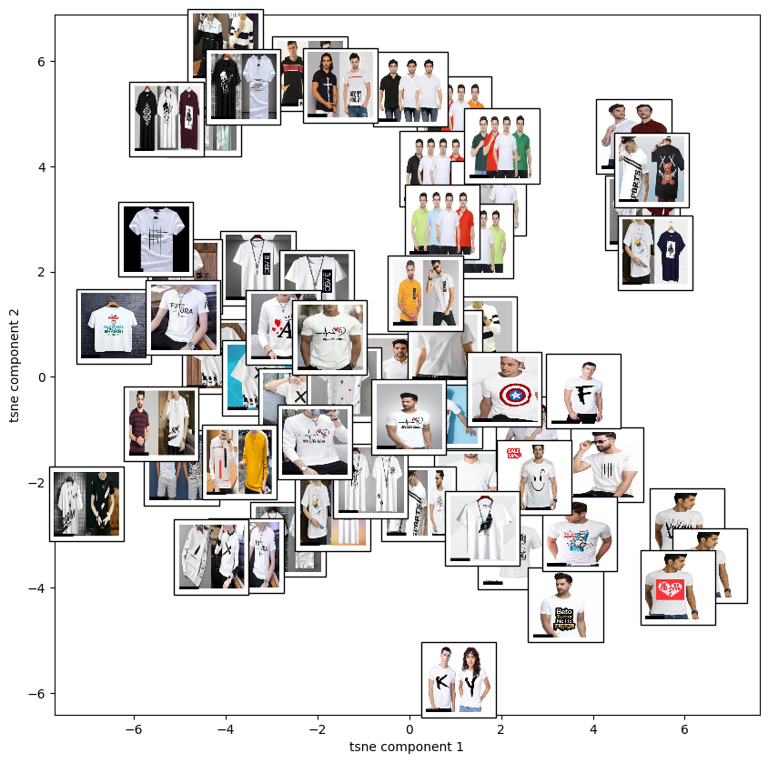

* *The component 1 captures the exsistence of models in the pictures. It is evident that at left there are very few pictures with models in the picture and towards right from middle every picture has model in each picture.*
* *The component 2 captures the variations in the design of Tshirts. From the image we could observe that the content of tshirts is varying throughout from top to bottom.*

1. **<Category, attribute> : <Sarees, solid>**

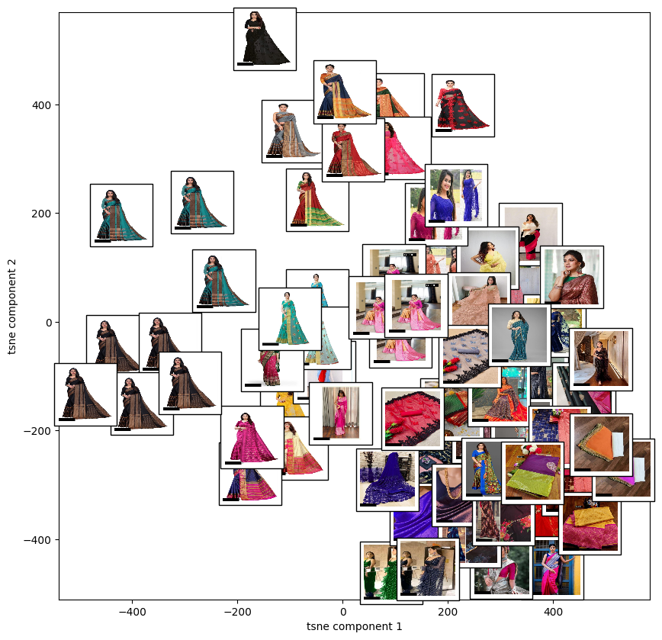

* *The component 1 captures variation of the solid colours of the saree. It is evident that there exists variation in colour from left to right.*
* *The component 2 captures the variations in the design of texture of prints on sarees. There exists variety of designs on the sarees from bottom to top.*

1. **<Category, attribute> : <Sarees, zari>**

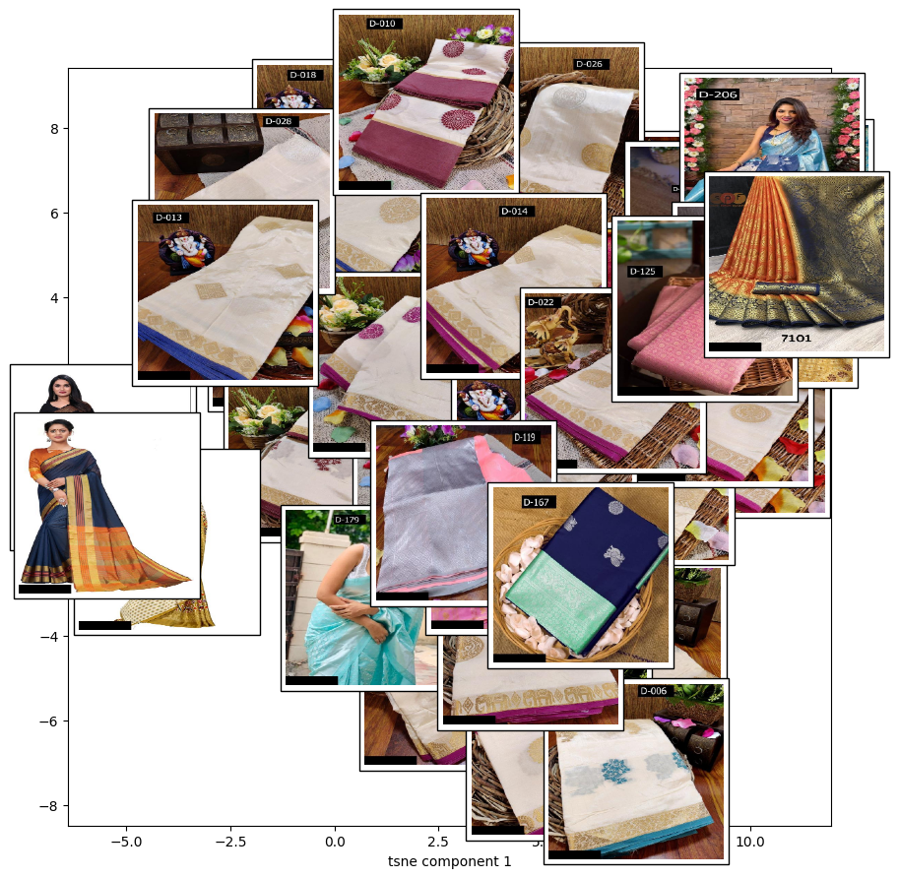

* *The component 1 captures the variations in the design of texture of prints on sarees. There exists variety of designs on the sarees from left to right.*
* *The component 2 captures variation of the border colours of the sarees. It is evident that there exists variation in border colour from bottom to top.*

1. **<Category, attribute> : <Women Tshirts, Loose>**

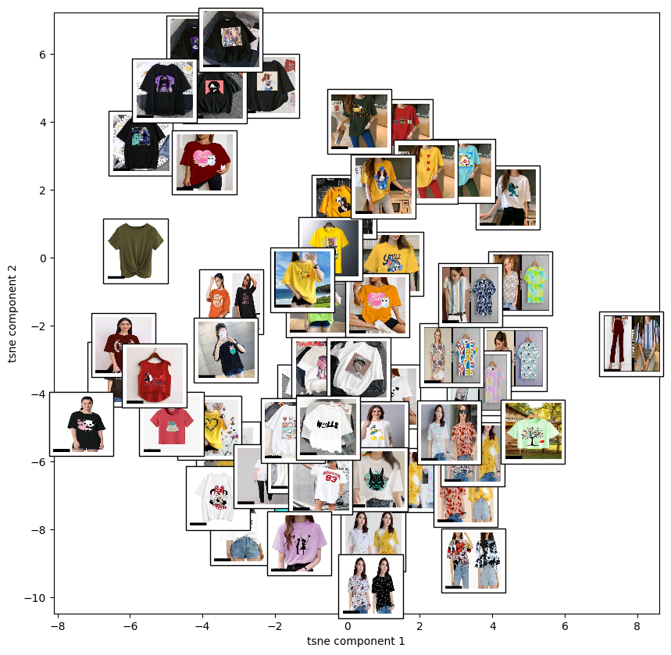

* *The component 1 captures the variations in the content of prints on Tshirts. There exists variety of contents printed on the Tshirts from left to right.*
* *The component 2 captures variation of the colours of the Tshirts. It is evident that the tshirts are lighter colour at the bottom when compared to the tshirts at top.*

1. **<Category, attribute> : <Women Tshirts, Maroon>**

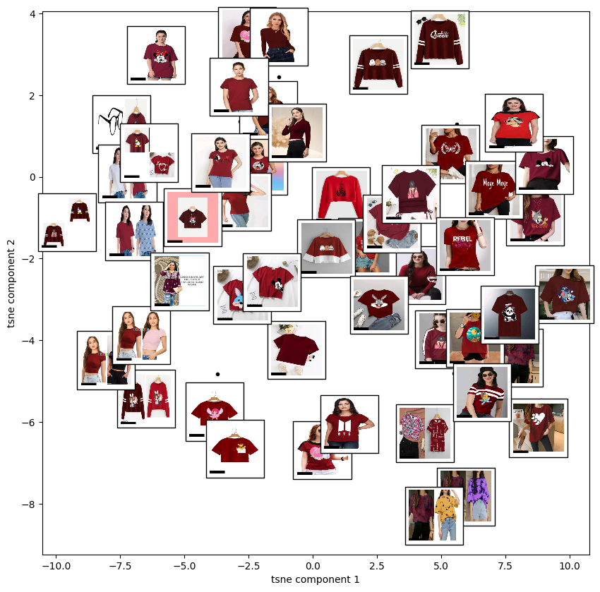

* *The component 1 captures variation of the shade of maroon on the Tshirts. It is evident that the maroon shade is lighter towards images in the left compared to images in the right.*
* *The component 2 captures the variations in the content of prints on Tshirts. There exists variety of contents printed on the Tshirts from bottom to top.*

1. ***<Category, attribute> : <Women Tops & Tunics, Blue>***

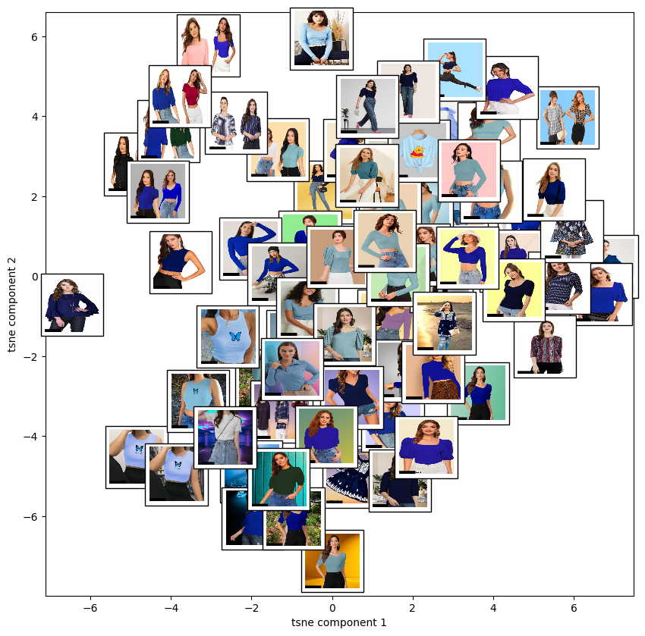

* *The component 1 captures the variations of the sleeves length and style. It is evident from image that images in the left have half sleeves and most of the images in the right have full sleeves and there exists variations in the style of tops as well.*
* *The component 2 captures the variations of the colours of the blue top. Three different colours exists while traversing through images from bottom to top.*

1. ***<Category, attribute> : <Women Tops & Tunics, Boxy>***

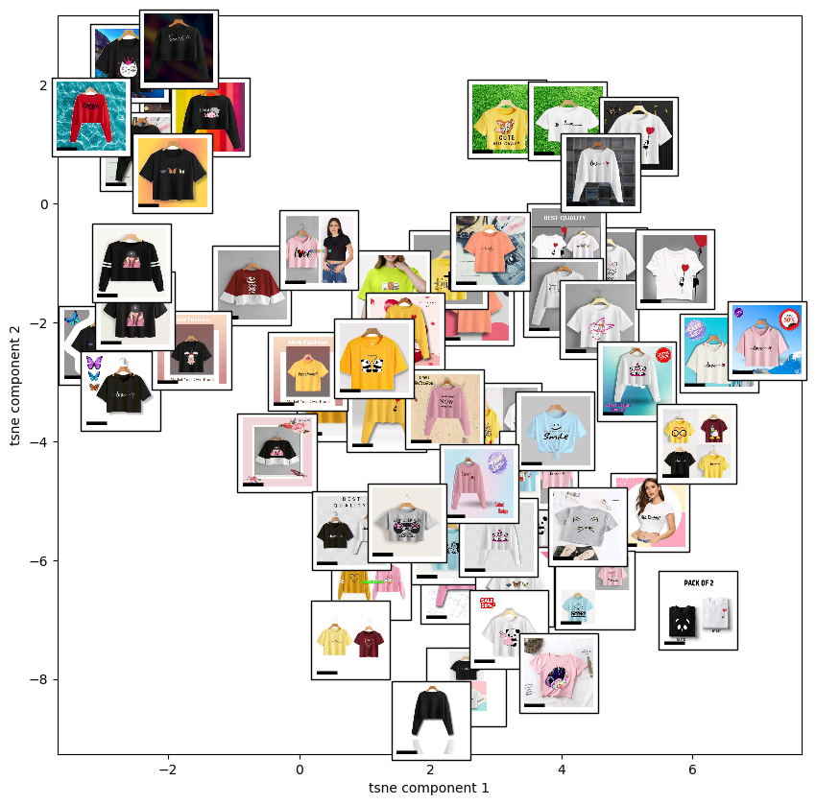

* *The component 1 captures variation of the colours of the Tops. It is evident that the colors are darker for the tops at the left when compared to the tops at right.*
* *The component 2 captures the design on the tops and the variation of sleeves from bottom up. It is evident that there exsists a minimum of 3 variations of sleeves design from bottom up and the design of pattern or content is changing in all tops from bottom up.*

Isomap Visualizations:

1. **<Category, attribute> : <Kurti, Black>**

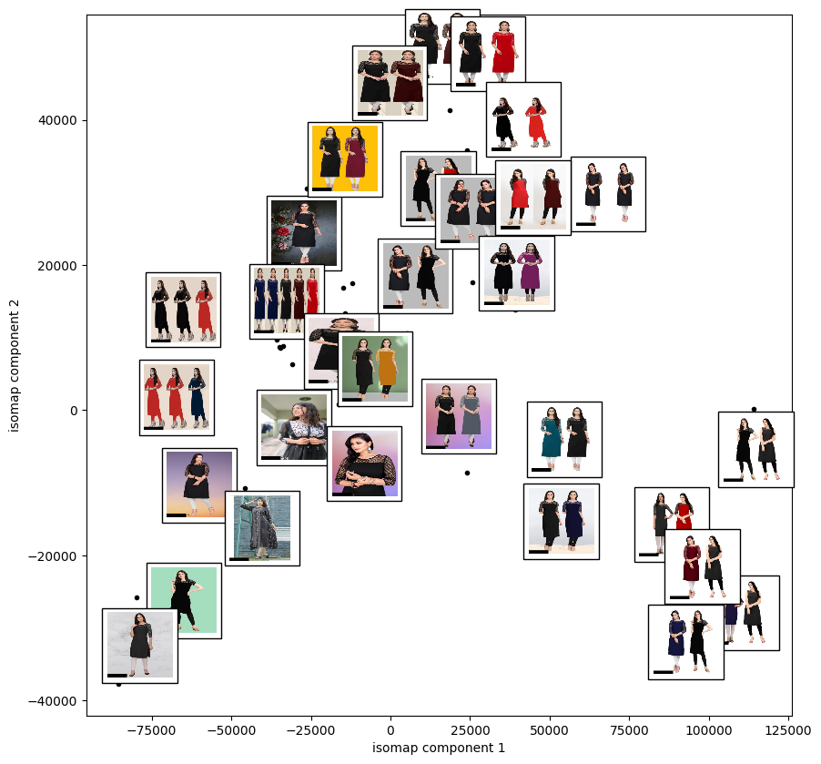

* *The component 1 captures the variations in the background colour as it is evident that the pictures in the left have coloured background and most of the pictures to the right have white background.*
* *The component 2 captures the different poses of model and the colours of kurtis in the picture. It is evident from the picture that there exists lots of variations in the pose from bottom* and the colours differs in the kurtis worn by models.

*2.* ***<Category, attribute> : <Kurti, aline>***

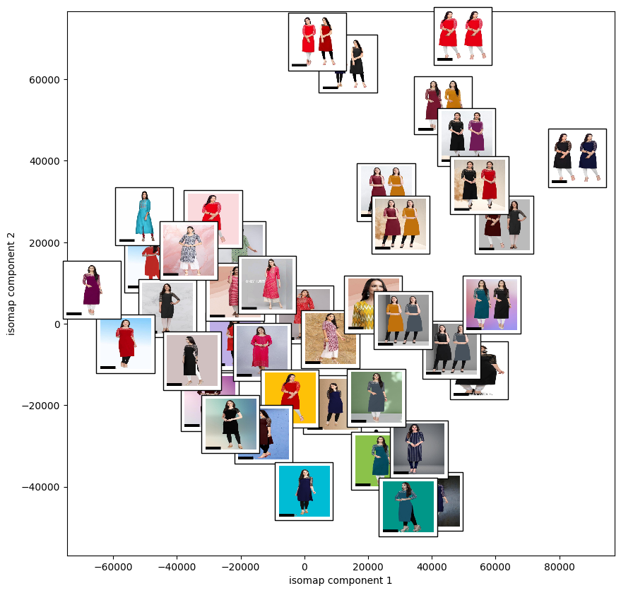

* *The component 1 captures the number of models in the images. All the images to the left have only one model in the image and all the images to the right have two models in the images.*
* *The component 2 captures the variations in the colour of the kurtis and the design of the kurtis. From the image we could observe that the colour of the kurtis is lighter and brighter at the top when compared to the middle and bottom sides. The kurtis have some kind of design at the top at top and few at middle where as all the kurtis at bottom have plain design.*

**3. <Category, attribute> : <Men Tshirts, polo>**

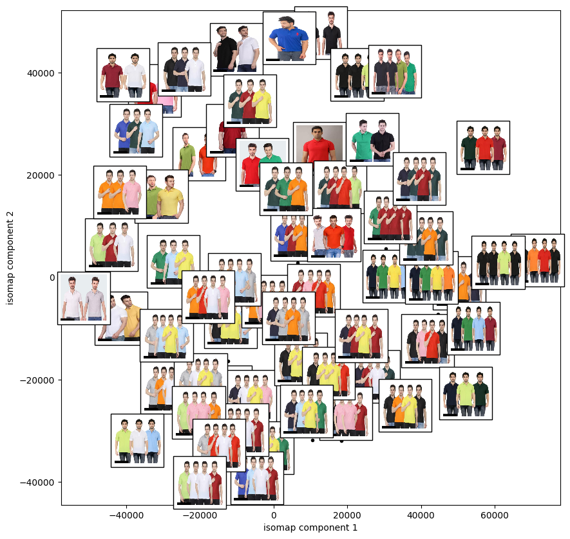

* *The component 1 captures the variations in the colour of Tshirts. From the image we could observe that the colour of tshirts is lighter at left when compared to the images towards right.*
* *The component 2 captures the number of models in the pictures. It is evident that at top there are fewer models in the picture and towards bottom there 4 models in each picture.*

***4.* *<Category, attribute> : <Men Tshirts, white>***

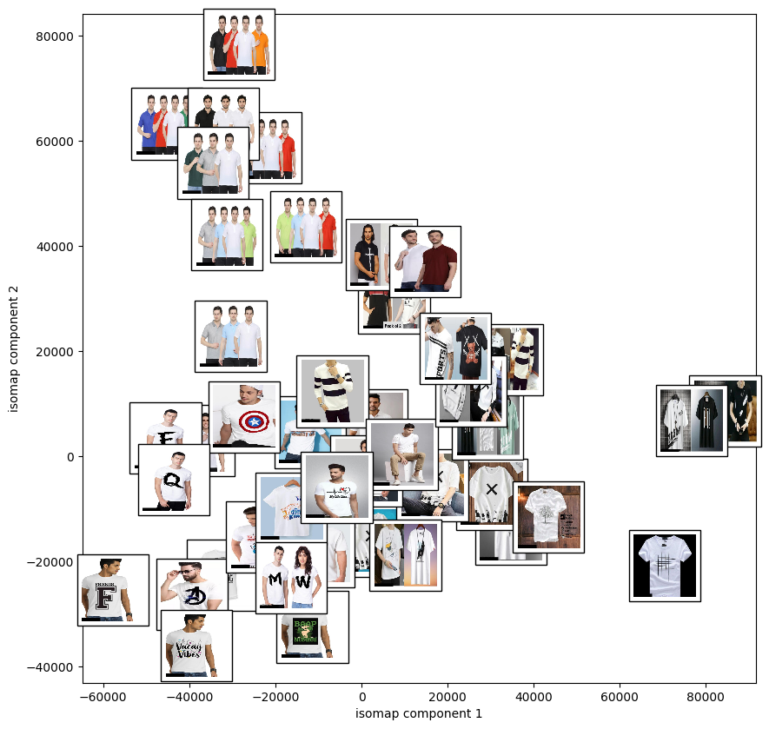

* *The component 1 captures the existence of models in the pictures. It is evident that all the images in the left have models in it and as we move towards right existence of model’s reduces to zero.*
* *The component 2 captures the variations in the design of Tshirts. From the image we could observe that the content of tshirts is varying throughout from top to bottom. At top we have t shirts which are plain as we move towards the bottom the variations in the contents of design on t shirts increase.*

**5. <Category, attribute> : <Sarees, solid>**

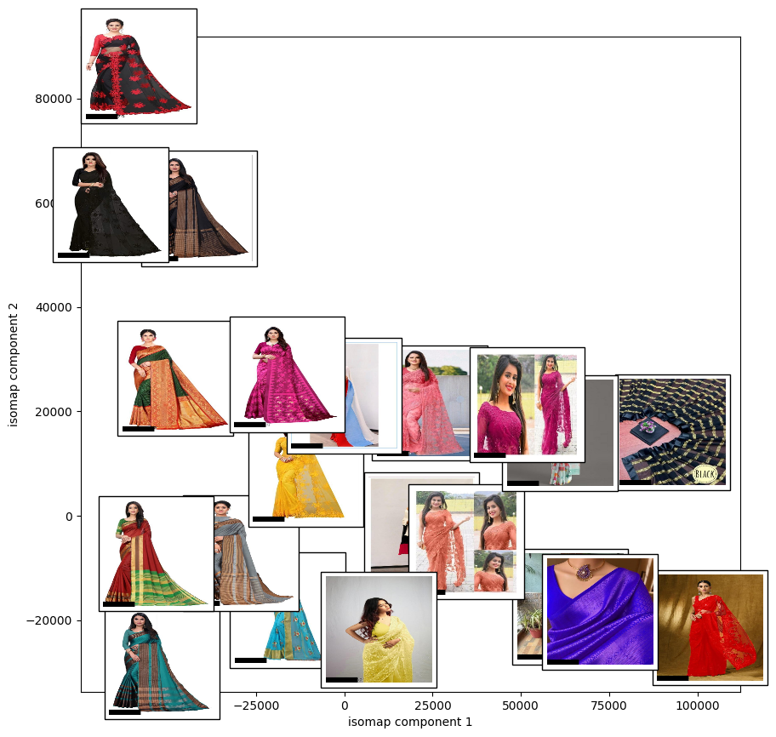

* *The component 1 captures the variations in the design of texture of prints on sarees. There exists variety of designs on the sarees from left to right. At left we have images of sarees containing different designs and textures and we move towards the right we have sarees of plain designs with minimal designs.*
* *The component 2 captures variation of the solid colours of the saree. It is evident that there exists variation in colour from top to bottom.*

**6.<Category, attribute> : <Sarees, zari>**

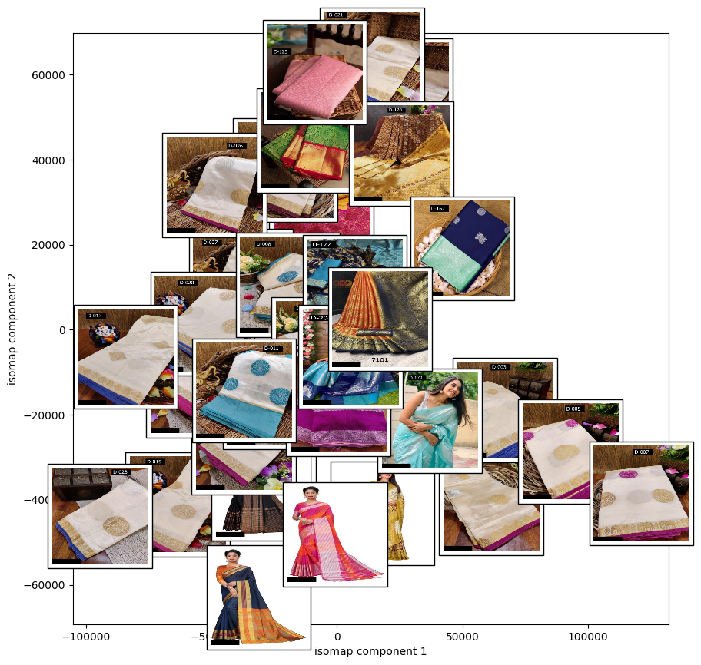

* *The component 1 captures the variations in the design of texture of prints on sarees. There exists variety of designs on the sarees of different patterns from left to right.*
* *The component 2 captures variation of the border colours of the sarees. It is evident that there exists variation in border colour from bottom to top from dark shade of pink to diff shades of blue and other colours.*

**7.<Category, attribute> : <Women Tshirts, Loose>**

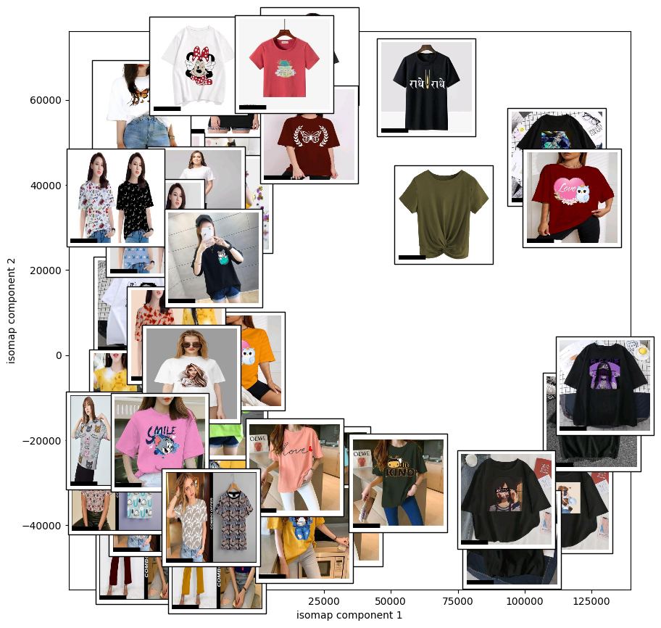

* *The component 1 captures variation of the colours of the Tshirts. It is evident that the tshirts are lighter colour at the left when compared to the tshirts at right. Towards right t shirts colors are darker.*
* *The component 2 captures the variations in the content of prints on Tshirts. There exists variety of contents printed on the Tshirts from top to bottom.*

**8. <Category, attribute> : <Women Tshirts, Maroon>**

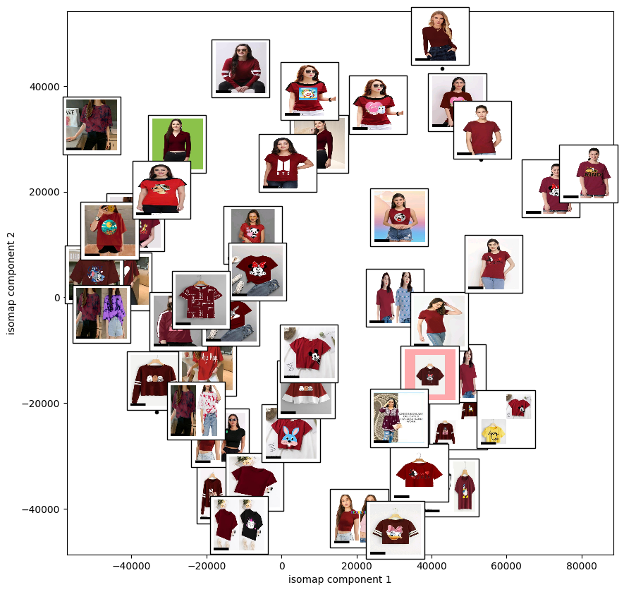

* *The component 1 captures the variations in the content of prints on Tshirts. There exists variety of contents printed on the Tshirts from left to right. The design on the tshirts reduce as we move towards the right.*
* *The component 2 captures variation of the shade of maroon on the Tshirts. It is evident that the maroon shade is lighter for the images in the top compared to images at the bottom.*

**9. <Category, attribute> : <Women Tops & Tunics, Blue>**

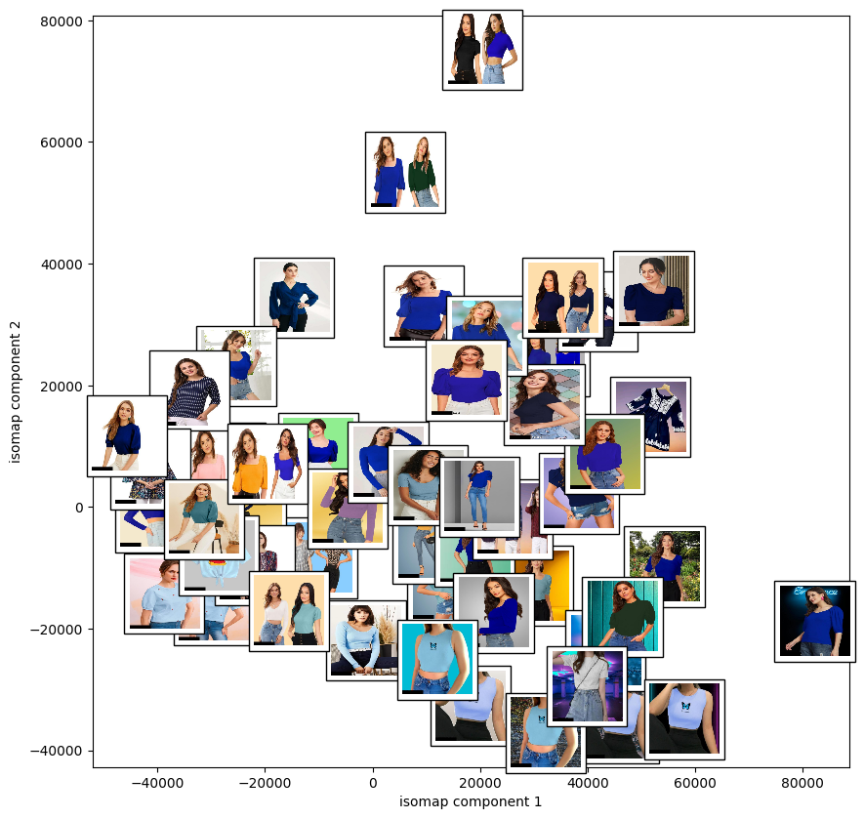

* *The component 1 captures the variations of the style of the tshirts. It is evident from image that images in the left have half sleeves, lighter colour with some design and most of the images in the right have full sleeves darker shade of blue. It also captures the variations in the model’s poses. Models have posed in different ways for images in the left compared to the right.*
* *The component 2 captures the variations of the colours of the blue top. Three different colours exists while traversing through images from bottom to top.*

**10. <Category, attribute> : <Women Tops & Tunics, Boxy>**

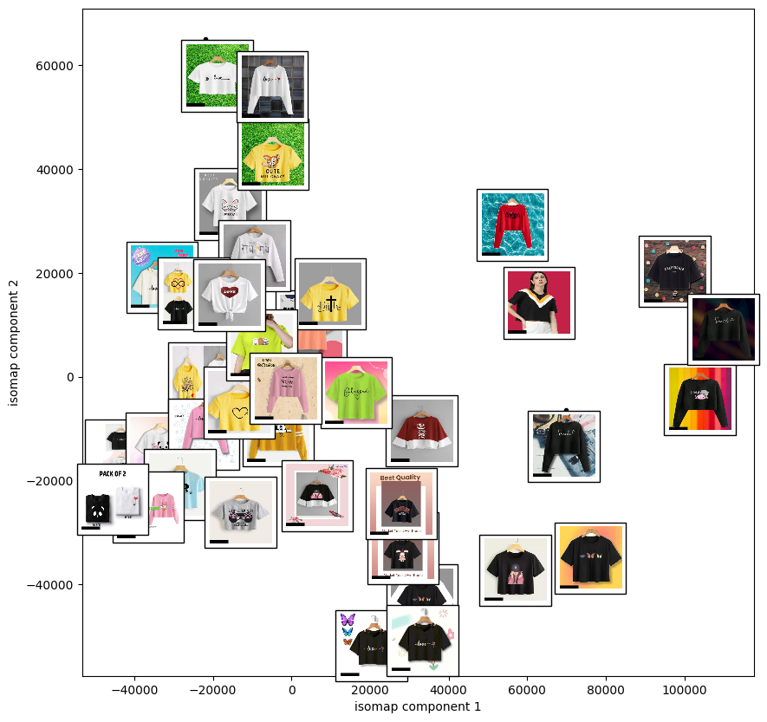

* *The component 1 captures variation of the colours of the Tops. It is evident that the colors are darker for the tops at the right when compared to the tops at left.*
* *The component 2 captures the design on the tops and the variation of sleeves from bottom up. It is evident that there exsists a minimum of 3 variations of sleeves design from bottom up(Full sleeves at top and middle, half sleeves at bottom) and the design of pattern or content is changing in all tops from bottom up.*

*Submitted by,*

*Manoj Kumar. CM*

*DA24S018*